Massachusetts Department of Revenue Division of Local Services
Amy A. Pitter, Commissioner Robert G. Nunes, Deputy Commissioner & Director of Municipal Affairs

Board of Selectmen
Town of Chilmark
Town Hall
Chilmark, Mass. 02535 February 15, 2013

Dear Board Members:

As of the E-mailing of this letter, the Annual City and Town Financial Report for the Fiscal Year ended June 30, 2012 (Schedule A) which was due from your community on October 31, 2012, has not been submitted on the Gateway system to the Bureau of Accounts.

The information in this report is added to DOR’s Municipal Data Bank and is used by many state agencies, the legislature and the executive administration for program research and analysis that may determine grants or policy. The data is also provided by DOR to the United States Census Bureau for use by federal agencies.

We must also advise that the General Laws Chapter 58, §18F, authorizes the Commissioner of Revenue to withhold payment of state aid to a community which has not filed their Schedule A Report. Due to the long overdue status of this report, we intend to withhold your March 31, 2013 quarterly local aid payment. In order to receive your March distribution on time, DLS must receive your Schedule A Form by March 22, 2013.

Your Bureau of Accounts field representative is available to answer any questions you have regarding this matter.

Sincerely,

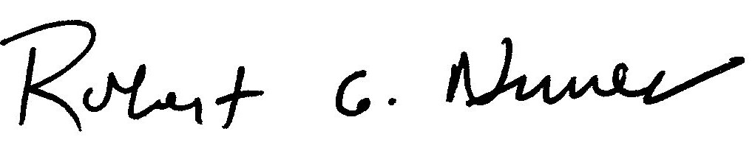

Robert G. Nunes
Deputy Commissioner

Cc: Executive Secretary

